Transient Behavior

ECE 09414 - 2 VLSI

Dr. Hanafi

Everett Jones

10/3/17

I. Introduction

The purpose of this procedure was to further our understanding of Cadence through the use of the symbol creation feature. With this feature the inverter symbol was able to be created from a previously made inverter circuit. This symbol was then used to create a circuit containing 11 inverters in a series in order to see how they react when a signal is put through them.

II. Procedure

Using Cadence the previously made inverter circuit was utilized in order to create an inverter symbol. This symbol was then used to create a circuit with 11 of the inverters in series. This circuit was used to show how a signal put through the circuit would react. The circuit can be seen in Figure 1 and the graph created from the outputs and inputs of various inverters in the circuit can be seen in Figure 2. From the graph in Figure 2 the delay propagation can be found. This can be found through the use of the built in calculator or by using the graph to determine points on the rises and falls of the signals and calculating the time by hand.

III. Results

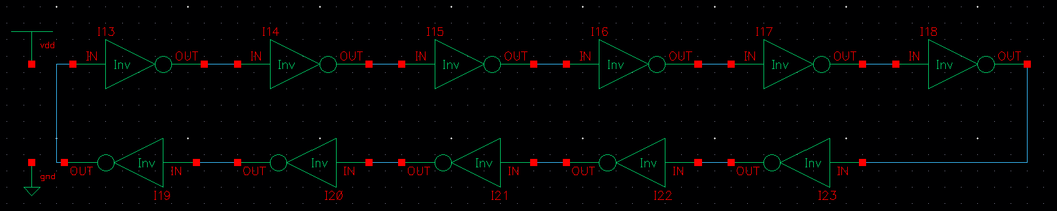

Figure 1: Schematic of the 11 inverters in series..

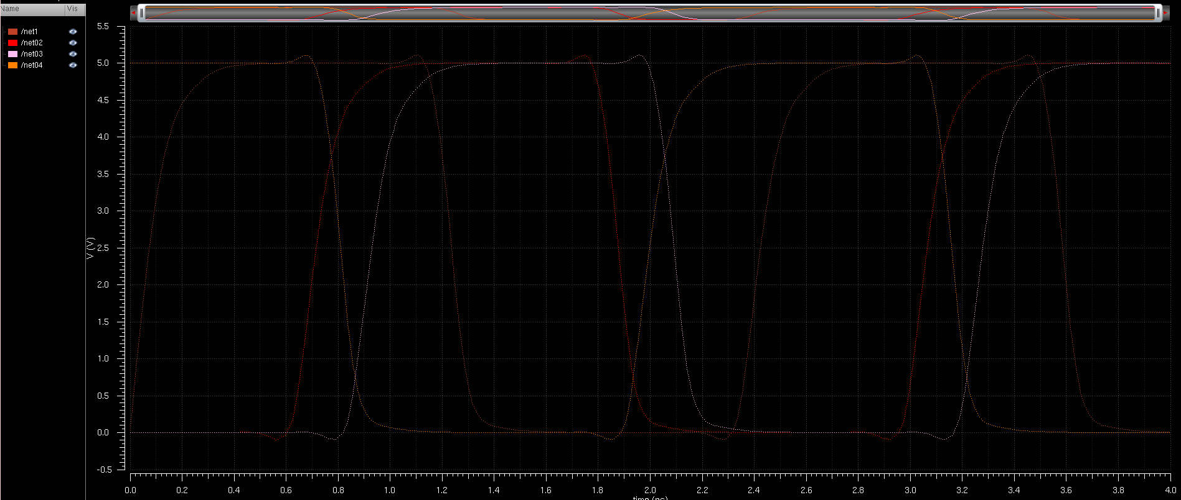

Figure 2: Graph of the rise and fall of various points on the inverter circuit.

IV. Conclusions

From this procedure it can be seen that the inverters create a small delay between the rise and fall of the signals between any two inverters. These signals have a very small delay, the time between a 50% fall to a 50% rise being only 2.35 ns. The delay between a 90% fall and 10% rise being only 138 ps and the 10% rise to 90% fall being only 350 ps. These times make the change nearly instant, but when scaling up these circuits these delays become crucial to the speed of the circuits they are used in.